# Oop lab 3 assignment

## NAME-FARHAN JAFFER

## ROLL-2105714

## SECTION -CSE01

Q1wap to represent the class student with following specifications-->

private members--> are roll num, name , six subjects name , total

public numbers--> input function for resp data members

display the grade

if marks in between 91-100 o grade

81-90 e grade

71-80 a grade

61-70 b grade below the above marks f grade

A1.

#include <iostream>

using namespace std;

struct subject{

int maths;

int sst;

int eng;

int hin;

int sci;

int cs;

};

class student{

private:

string name;

int roll;

int total;

struct subject sub;

public:

void get_name_roll_subject(){

cout<<"\nEnter Name ";cin>>name;

cout<<"\nEnter Roll ";cin>>roll;

cout<<"\nEnter Marks in Subject ";cin>>sub.maths>>sub.cs>>sub.eng>>sub.hin>>sub.sci>>sub.sst;

totalmarks();

}

void totalmarks(){

total=sub.maths+sub.cs+sub.eng+sub.hin+sub.sci+sub.sst;

}

void grade(){

totalmarks();

if (total/6>=91){

cout<<"\nGrade O";

}

else if (total/6>=81){

cout<<"\nGrade E";

}

else if (total/6>=71){

cout<<"\nGrade A";

}

else if (total/6>=61){

cout<<"\nGrade B";

}

else{

cout<<"\nYou Failed";

}

}

};

int main()

{

student student_a;

student_a.get_name_roll_subject();

student_a.grade();

return 0;

}

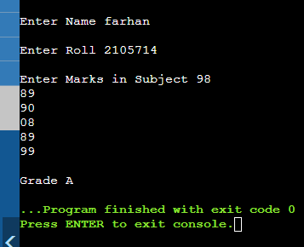

Q2..wap to represent bank account wiht following specifications

private -->name of depositer,type of account,account number,balance amount in the account

public-->to assign initial values, to withdraw an amount after checking balance, deposit an amount, display name and balance...

A2..

#include <iostream>

using namespace std;

class bankacc{

private:

int balance=0;

int account_number;

string type;

string name;

public:

void name_type_accnum(){

cout<<"\nEnter Name ";cin>>name;

cout<<"\nEnter Type ";cin>>type;

cout<<"\nEnter Account Number ";cin>>account_number;

}

void display_info(){

cout<<"\n\nInfo";

cout<<"\nName "<<name;

cout<<"\nBalance "<<balance;

}

void deposit(){

int num;

cout<<"\nHow much to deposit : ";cin>>num;

balance=balance+num;

cout<<"Current Balance "<<balance;

}

void withdraw(){

if (balance>=1000){

int num;

cout<<"\nHow much to withdraw : ";cin>>num;

if (balance>=num){

balance=balance-num;

cout<<"Current Balance "<<balance;

}

else{

cout<<"\nWithdraw Unsuccessful";

}

}

else{

cout<<"\nInsufficiat Balance";

}

}

};

int main()

{

bankacc person1;

person1.name_type_accnum();

person1.deposit();

person1.withdraw();

person1.display_info();

return 0;

}

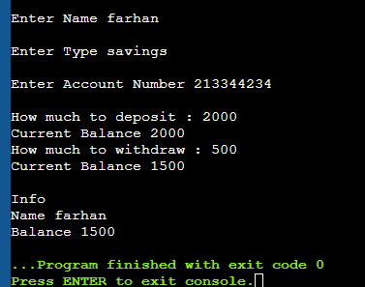

# NAME- FARHAN JAFFER

# ROLL -2105714